”Surface Scanner” 1984 Megastar Games

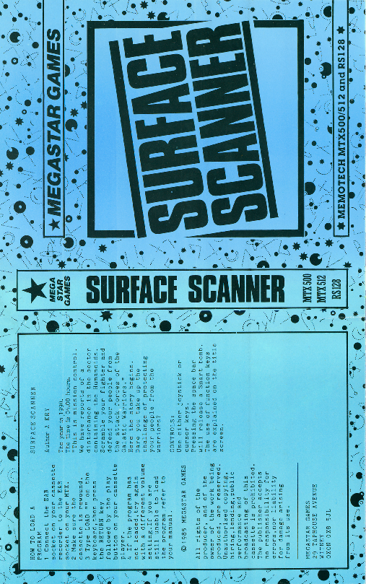

Scanned by Medion 600dpi “true color magazine”z

